Chapter no.3: page no.110-161
Organizational structures
Instructor: sir Junaid
Question no.1:
Explain major factors that caused the onset of the organizational revolution?
Answer:
Wallace identified four major factors that caused the onset of the organizational revolution:
- The technology revolution (complexity and variety of products, new materials and processes, and the effects of massive research)
- Competition and the profit squeeze (saturated markets, inflation of wage and material costs, and production efficiency)
- The high cost of marketing
- The unpredictability of consumer demands (due to high income, wide range of choices available, and shifting tastes)
Question no.2:
“Traditional structure may not be adequate for managing project”, explain why?
Answer:
Much has been written about how to identify and interpret those signs that indicate that a new organizational form may be necessary. According to Grinnell and Apple, there are five general indications that the traditional structure may not be adequate for managing projects:
- Management is satisfied with its technical skills, but projects are not meeting time, cost, and other project requirements.
- There is a high commitment to getting project work done, but great fluctuations in how well performance specifications are met.
- Highly talented specialists involved in the project feel exploited and misused.
- Particular technical groups or individuals constantly blame each other for failure to meet specifications or delivery dates.
- Projects are on time and to specifications, but groups and individuals are not satisfied with the achievement.
Question no.3:
What are the checklist that explores a company’s tasks, social climate, and relationship to the environment?
Answer:
- To what extent does the task of organization call for close control if it is to be performed efficiently?
- What are the needs and attitudes of the people performing the tasks? What are the likely effects of control mechanisms on their motivation and performance?
- What are the natural social groupings with which people identify themselves? To what extent are satisfying social relationships important in relation to motivation and performance?
- What aspect of the organization’s activities needs to be closely integrated if the overall task is to be achieved?
- What organizational measures can be developed that will provide an appropriate measure of control and integration of work activities, while at the same time meeting the needs of people and providing adequate motivation?
- What environmental changes are likely to affect the future trend of company operations? What organizational measures can be taken to insure that the enterprise responds to these effectively?
Question no.4:
Elaborate organizational work flow?
Answer:
Organizations are continually restructured to meet the demands imposed by the environment. Restructuring can change the role of individuals in the formal and the informal organization.
Many researchers believe that the greatest usefulness of behavioralist lies in the ability to help the informal organization adapt to changes and resolve the resulting conflicts.
Whatever organizational form is finally selected, formal channels must be developed so that each individual has a clear description of the authority, responsibility, and accountability necessary for the work to proceed.
In the discussion of organizational structures, the following definitions will be used:
- Authority is the power granted to individuals (possibly by their position) so that they can make final decisions.
- Responsibility is the obligation incurred by individuals in their roles in the formal organization to effectively perform assignments.
- Accountability is being answerable for the satisfactory completion of a specific assignment. (Accountability = authority + responsibility.)
Authority and responsibility can be delegated to lower levels in the organization, whereas accountability usually rests with the individual. Yet many executives refuse to delegate and argue that an individual can have total accountability just through responsibility.
Even with these clearly definable divisions of authority, responsibility, and accountability, establishing good relationships between project and functional managers can take a great deal of time, especially during the conversion from a traditional to a project organizational form. Trust is the key to success here. The normal progression in the growth of trust is as follows:
- Even though a problem exists, both the project and functional managers deny that any problem exists.
- When the problem finally surfaces, each manager blames the other.
- As trust develops, both managers readily admit responsibility for the problems.
- The project and functional managers meet face-to-face to work out the problem.
- The project and functional managers begin to formally and informally anticipate problems.
Question no.5:
Draw the traditional management structure?
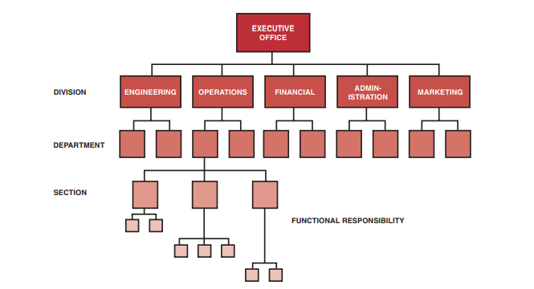
Question no.6:
Write down advantages and disadvantages of the classical organization?
Answer:
Advantages of classical organization:
- Easier budgeting and cost control are possible.
- Better technical control is possible.
  - Specialists can be grouped to share knowledge and responsibility.
  - Personnel can be used on many different projects.
  - All projects will benefit from the most advanced technology (better utilization of scarce personnel)
- Flexibility in the use of manpower.
- A broad manpower base to work with.
- Continuity in the functional disciplines; policies, procedures, and lines of responsibility are easily defined and understandable.
- Admits mass production activities within established specifications.
- Good control over personnel, since each employee has one and only one person to report to.
- Communication channels are vertical and well established.
- Quick reaction capability exists but may be dependent upon the priorities of the functional managers.
Disadvantages of the classical organization:
- No one individual is directly responsible for the total project (i.e., no formal authority; committee solutions).
- Does not provide the project – oriented emphasis necessary to accomplish the project tasks.
- Coordination becomes complex, and additional lead time is required for approval of decisions.
- Decisions normally favor the strongest functional groups.
- No customer focal point.
- Response to customer needs is slow.
- Difficulty in pinpointing responsibility; this is the result of little or no direct project reporting, very little project - oriented planning, and no project authority.
- Motivation and innovation are decreased.
- Ideas tend to be functionally oriented with little regard for ongoing projects.

